PHASE 5: PROJECT DEVELOPMENT PHASE

1. Prepare the Spreadsheet
A new Google Spreadsheet is created with sample employee data.
The spreadsheet is downloaded as Sample Spreadsheet.xlsx.

2. Create Custom Table
Navigate to:
Tables → Create New
Create the table:
Label: Employee Test
Name: u_employee_test
The following fields are added:
- Employee ID
- Employee Name
- Email
- Department
- Location

3. Create Import Set Table
Navigate to:
Application Navigator → Load Data
Create the Import Set table:
Label: Employee Import
Name: u_employee_import
After submitting, the Import Set table is created.

4. Create Transform Map
Create a Transform Map with:
Name: Sample Spreadsheet Import
Source Table: Employee Import
Target Table: Employee Test
Use Auto Map Matching Fields and Mapping Assist to map the source and target fields.

5. Transform Data
Click Transform and execute the transformation.
The imported records are created in the Employee Test table.

6. Enable Coalesce
Open the Transform Map and configure a suitable field as Coalesce = True.
This prevents duplicate records during repeated imports.

7. Create Reports
Create three reports:
- Employees by Department
- Employees by Location
- Employee List Report

8. Create Dashboard
Create an Employee Analytics Dashboard and add the three reports to the dashboard.

Transform Data & Validate
Navigation:
- Open Employee Test Table from application navigator as shown below.

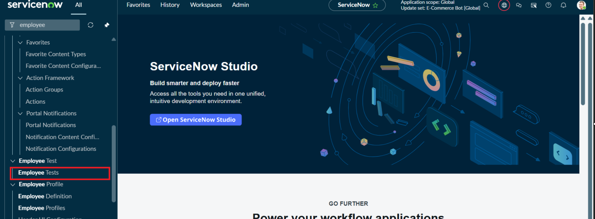

- As our import got succeeded, all the records are created in the Employee Test Table.

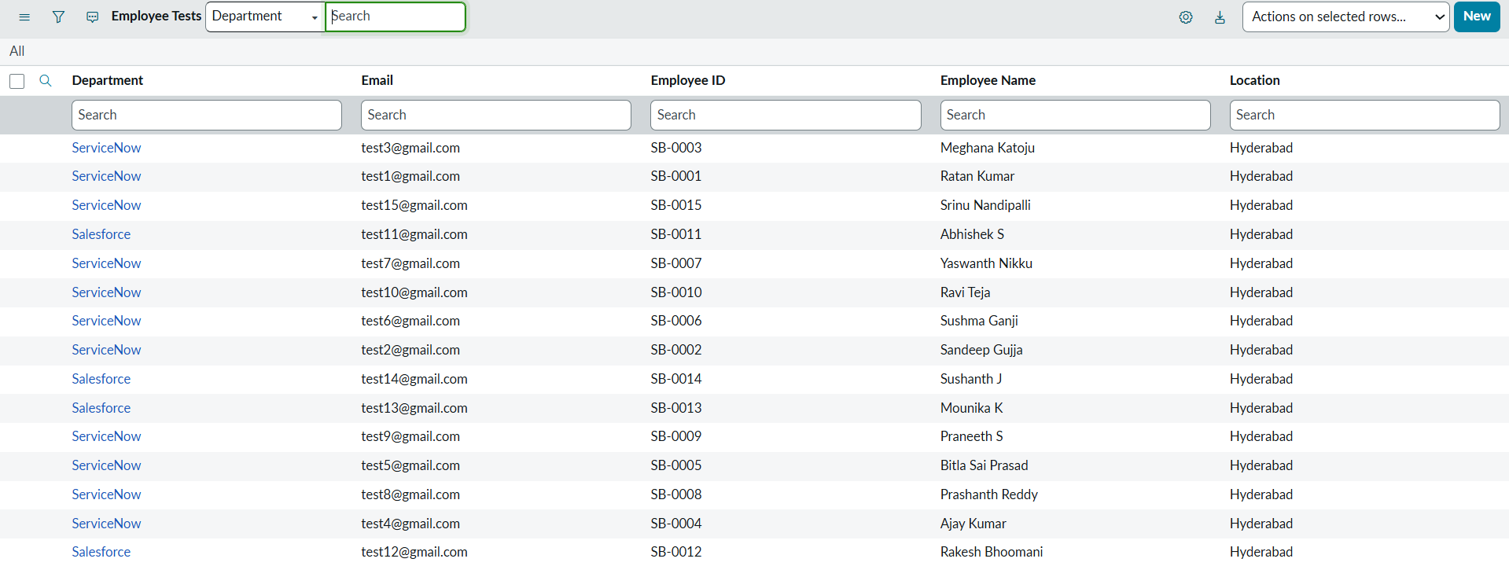

- Make sure you rearrange the fields accordingly by using Personalised List Columns
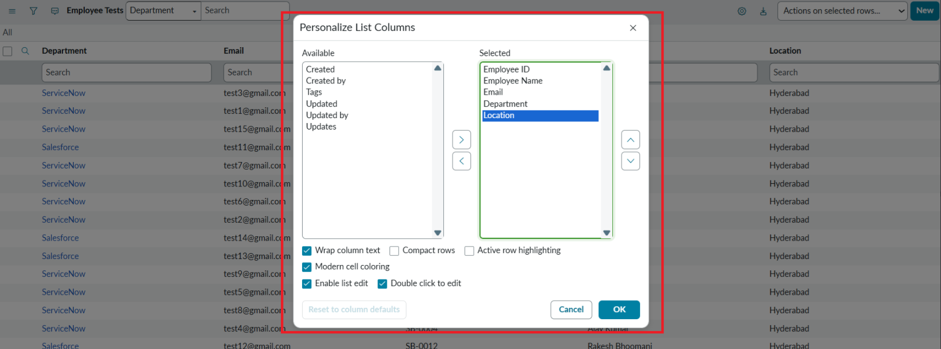

Click on OK

Final Result:
All the records are successfully imported into the ServiceNow system with Import Set, Transform Map.

